**Task 7 : Identify and Remove Suspicious Browser Extensions**

**Deliverables:** List of suspicious extensions found and removed (if any)

So, the only suspicious extension found in our chrome web browser is **Shazam Extension.**

We found **Shazam Extension** as ‘suspicious’ due to its **security issues arising**. Thus, removed it from our chrome extension.



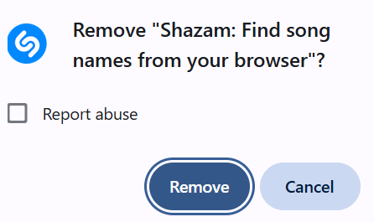

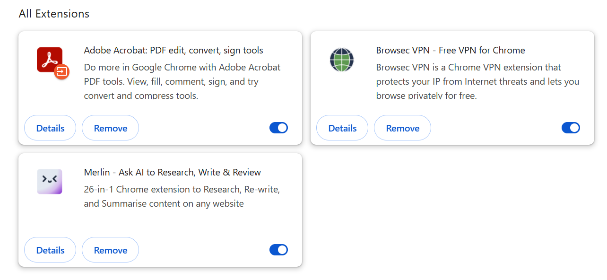

Also, **Adobe Acrobat:**

Changed the site access to **“on click”** from **“all sites”** which changes automatically in the other two too, i.e., **Merlin AI** and **Browsec VPN.**

